Epsom & Ewell
14
v
Ash United
Saturday, 8th February 2020 – 3.00 p.m.

Good afternoon and welcome to High Road for a League match with Ash United. We welcome their players, supporters and officials and hope they have a safe journey home.

We have met our opponents on twenty-two previous occasions, with many having been played since 2006 since we transferred back to the Combined Counties League. Matches have resulted mostly in our favour during that time, but not always, and although we have won our last couple of away matches at Youngs Drive, we were held to a 1-1 draw here last January, despite being in good form.

Of course, we are in very good form ourselves right now, and for the first time in a while we must be wary of the dangers of over-confidence. I’m sure Sam and Tim will be stressing that to our boys before the match.

Attendances have been rather disappointing recently, despite the excellent form we are showing. As supporters it is down to all of us to come along as regularly as possible and we also need to remind our friends to come down too. Not only do our boys need your support right now, they actually deserve your support, so let everyone know and let’s see a much bigger attendance here for the next home match two weeks today.

We were last here on Tuesday when we faced Nottsborough in the Surrey Premier Cup and we produced one of our best performances in months, if not years when we defeated them 3-0. The work rate and desire from our players was something that has often been missing over the recent years and long may it continue. We face Dorking Wanderers Reserves at Meadowbank in the Quarter-Final on a date to be confirmed. Once we know more, I will of course let you know and this also goes for our two outstanding League matches at Chessington & Hook United and Eversley & California.

Going forward we face a very tough looking League match at Farnham Town on Saturday. As I write, we have five wins and one draw in 2020, while they have seven wins! As I wrote earlier, we then return here on Saturday 22nd February for another League match against our local rivals Chessington & Hook United. Bring your friends!

Enjoy the game!

Rich

You can follow us on social media – just see the inside cover for details.

Cover photo by Gemma Jarman

Jordan-Boateng Anderson smashes in our fourth goal in the 4-0 home win over Cove on Saturday 25th January

Cherry Red Records Combined Counties League
Division One Table 2019/20
incl Tuesday 4th February | P | W | D | L | F | A | Pts | GD | H | A

Jersey Bulls | 23 | 23 | 0 | 0 | 87 | 7 | 69 | +80 | 13/4 | 0-2
Farnham Town | 24 | 16 | 3 | 5 | 42 | 23 | 51 | +19 | 0-2 | 15/2
Bedfont & Feltham | 24 | 13 | 5 | 6 | 55 | 32 | 44 | +23 | 0-5 | 18/4
Sandhurst Town | 23 | 11 | 7 | 5 | 53 | 37 | 40 | +16 | 1-1 | 14/3
Tooting Bec | 23 | 11 | 6 | 6 | 54 | 32 | 39 | +22 | 2-2 | 1-2
Fleet Spurs | 24 | 12 | 1 | 11 | 49 | 38 | 37 | +11 | 3-5 | 1-2
Walton & Hersham | 22 | 11 | 3 | 8 | 65 | 46 | 36 | +19 | 31/3 | 3-6
Kensington & Ealing Boro | 21 | 11 | 1 | 9 | 45 | 42 | 34 | +3 | 2-0 | 1-3
Epsom and Ewell | 24 | 10 | 4 | 10 | 48 | 48 | 34 | 0 | x | x
Bagshot | 24 | 9 | 5 | 10 | 40 | 46 | 32 | -6 | 4/4 | 1-2
AFC Hayes | 19 | 8 | 4 | 7 | 47 | 43 | 28 | +4 | 1-4 | 28/3
Dorking Wanderers Res | 23 | 8 | 4 | 11 | 50 | 57 | 28 | -7 | 2-2 | 11/4
Cove | 23 | 8 | 4 | 11 | 37 | 66 | 28 | -29 | 4-0 | 2-2
Ash United | 24 | 9 | 0 | 15 | 38 | 63 | 27 | -25 | 8/2 | 2-1
Westside | 20 | 7 | 3 | 10 | 42 | 38 | 24 | +4 | 3-2 | 3-1
FC Deportivo Galicia | 26 | 6 | 6 | 14 | 42 | 76 | 24 | -34 | 3-0 | 3-2
British Airways | 24 | 6 | 5 | 13 | 35 | 64 | 23 | -29 | 3-0 | 29/2
Chessington & Hook United | 21 | 4 | 7 | 10 | 35 | 53 | 16* | -18 | 22/2 | tba
Godalming Town | 23 | 3 | 6 | 14 | 38 | 65 | 15 | -27 | 5-2 | 2-0
Eversley & California | 23 | 2 | 8 | 13 | 23 | 49 | 14 | -26 | 21/3 | tba
* Chessington & Hook United – three points deducted for playing an ineligible player on 3rd August v Godalming Town

Lucky Day? – 8th February
Played 11 - Won 6 Drawn 0 Lost 5 - For 20 Against 20 - PPG 1.64 - Above Average
Our Club record against Ash United
Played 22 - Won 12 Drawn 4 Lost 6 - For 53 Against 34 - PPG 1.82 - Good
Our Largest wins and losses against Ash United
24th January 1981 - W 6-0 - Surrey Senior Cup (A)
27th October 2009 - L 1-4 - Combined Counties League Premier Division (A)
Ash United‘s last visit
12th January 2019 - Drew 1-1 - Combined Counties League Division One

First Eleven Appearances - (max 29)
Name | Debut | 2019/20 |  |  |  | Career Totals
 |  | App | Sub | Tot | Goals | App | Sub | Tot | Goals
ANDERSON Jordan-Boateng | 11/01/2020 | 6 | 0 | 6 | 0 | 6 | 0 | 6 | 0
ACHEAMPONG Gideon | 11/01/2020 | 5 | 1 | 6 | 2 | 5 | 1 | 6 | 2
ASHTON Ben | 01/02/2020 | 2 | 0 | 2 | 0 | 2 | 0 | 2 | 0
BENNETT Bobby | 12/08/2018 | 23 | 3 | 26 | 14 | 64 | 3 | 67 | 37
BETANCOURT Steve | 18/08/2018 | 2 | 3 | 5 | 1 | 23 | 4 | 27 | 2
BONASS-WARD Joe | 10/08/2019 | 14 | 5 | 19 | 0 | 14 | 5 | 19 | 0
CAMPBELL Kieran* | 25/01/2020 | 0 | 1 | 1 | 0 | 59 | 4 | 63 | 2
CARNEY Billy* | 12/01/2019 | 1 | 2 | 3 | 2 | 13 | 7 | 20 | 8
CARTON Kyle* | 03/08/2019 | 4 | 0 | 4 | 0 | 4 | 0 | 4 | 0
CHIN Louis* | 08/12/2018 | 6 | 1 | 7 | 0 | 19 | 2 | 21 | 0
CONNELLY Lloyd | 14/10/2017 | 25 | 3 | 28 | 2 | 103 | 7 | 110 | 8
DAVIES Felix* | 03/08/2019 | 11 | 0 | 11 | 0 | 11 | 0 | 11 | 0
DUNCANSON Daniel | 25/01/2020 | 1 | 3 | 4 | 1 | 1 | 3 | 4 | 1
FRAY James | 12/11/2019 | 8 | 0 | 8 | 1 | 8 | 0 | 8 | 1
FUNNELL Toby* | 03/08/2019 | 13 | 1 | 14 | 1 | 13 | 1 | 14 | 1
GALLAGHER Jordan* | 07/08/2016 | 8 | 2 | 10 | 3 | 57 | 15 | 72 | 21
HALLIER-DEGALE Tyrell | 14/12/2019 | 0 | 2 | 2 | 0 | 0 | 2 | 2 | 0
HAYWOOD-ROYE Corey | 30/11/2019 | 2 | 1 | 3 | 0 | 2 | 1 | 3 | 0
HEAGNEY Adam | 16/08/2016 | 16 | 1 | 17 | 2 | 130 | 14 | 144 | 5
HENDRY Rob | 08/08/2015 | 13 | 7 | 20 | 7 | 123 | 31 | 154 | 53
KING Jahmahl | 26/10/2019 | 15 | 0 | 15 | 1 | 15 | 0 | 15 | 1
LEWIS Rory* | 03/08/2019 | 1 | 1 | 2 | 0 | 1 | 1 | 2 | 0
MARTIN Chaz-Lee* | 03/08/2019 | 8 | 1 | 9 | 2 | 8 | 1 | 9 | 2
MORGAN Sam | 11/09/2018 | 0 | 2 | 2 | 0 | 3 | 11 | 14 | 0
MURPHY Scott | 20/01/2007 | 27 | 0 | 27 | 5 | 118 | 2 | 120 | 14
MURPHY Todd | 27/11/2018 | 13 | 2 | 15 | 0 | 16 | 11 | 27 | 0
NIGHTINGALE Zak* | 03/08/2019 | 3 | 4 | 7 | 1 | 3 | 4 | 7 | 1
PINDER Marlon* | 13/01/2018 | 5 | 0 | 5 | 3 | 18 | 1 | 19 | 5
ROBERTS Liam | 12/08/2017 | 4 | 9 | 13 | 3 | 54 | 30 | 84 | 20
ROBINSON Jake | 23/02/2019 | 18 | 3 | 21 | 2 | 27 | 4 | 31 | 2
SEWELL Jacob | 01/02/2020 | 0 | 2 | 2 | 0 | 0 | 2 | 2 | 0
SKELLY Jacob | 11/01/2020 | 5 | 1 | 6 | 1 | 5 | 1 | 6 | 1
SMITH George* | 16/11/2019 | 1 | 4 | 5 | 0 | 1 | 4 | 5 | 0
SMITH Taryn | 28/10/2017 | 19 | 4 | 23 | 4 | 33 | 15 | 48 | 9
STRAKER Tariq | 16/11/2019 | 13 | 0 | 13 | 3 | 13 | 0 | 13 | 3
SULLIVAN Ryan* | 04/08/2018 | 1 | 0 | 1 | 0 | 31 | 2 | 33 | 0
TEIXEIRA Ricardo* | 19/10/2019 | 4 | 0 | 4 | 0 | 4 | 0 | 4 | 0
THOMPSON Ashley* | 21/08/2017 | 1 | 0 | 1 | 0 | 36 | 1 | 37 | 5
WHITE Sean* | 02/08/2014 | 9 | 4 | 13 | 0 | 38 | 29 | 67 | 9
YOUNG Conor | 07/03/2015 | 12 | 0 | 12 | 0 | 73 | 0 | 73 | 0
Own goal |  |  |  |  | 1
* Player has left the club

Latest Results and Fixtures
Surrey Premier Cup – Tuesday 4th February
Epsom & Ewell | 3-0 | Nottsborough
Combined Counties League – Tuesday 4th February
Bedfont & Feltham | 3-0 | Westside
Eversley & California | 2-2 | Chessington & Hook Utd
Farnham Town | 2-0 | Fleet Spurs
Sandhurst Town | 3-2 | Walton & Hersham
Combined Counties League – Saturday 8th February
British Airways | V | Farnham Town
Chessington & Hook Utd | V | Bagshot
Cove | V | Godalming Town
Epsom & Ewell | V | Ash United
Farnham Town | V | Westside
Kensington & Ealing Borough | V | AFC Hayes
Sandhurst Town | V | Jersey Bulls
Combined Counties League Cup Third Round – Tuesday 11th February
Camberley Town | V | Farnham Town
Sandhurst Town | V | Dorking Wanderers Reserves
Esoteric Division One Cup Third Round – Tuesday 11th February
Godalming Town | V | Jersey Bulls
Combined Counties League – Tuesday 11th February
Chessington & Hook United | V | British Airways
Combined Counties League Cup Second Round – Wednesday 12th February
Sutton Common Rovers | V | Spelthorne Sports
Combined Counties League – Saturday 15th February
AFC Hayes | V | Sandhurst Town
Ash United | V | FC Deportivo Galicia
Bedfont & Feltham | V | Fleet Spurs
Cove | V | British Airways
Farnham Town | V | Epsom & Ewell
Godalming Town | V | Eversley & California
Jersey Bulls | V | Kensington & Ealing Borough
Tooting Bec | V | Dorking Wanderers Reserves
Walton & Hersham | V | Chessington & Hook United
Westside | V | Bagshot
Combined Counties League Cup Third Round – Tuesday 18th February
AFC Hayes | V | Sheerwater
Latest Results and Fixtures
Combined Counties League – Tuesday 18th February
Cove | V | Kensington & Ealing Borough
Combined Counties League – Saturday 22nd February
Bagshot | V | Cove
British Airways | V | AFC Hayes
Dorking Wanderers Reserves | V | Walton & Hersham
Epsom & Ewell | V | Chessington & Hook Utd
Eversley & California | V | FC Deportivo Galicia
Fleet Spurs | V | Sandhurst Town
Jersey Bulls | V | Bedfont & Feltham
Kensington & Ealing Borough | V | Farnham Town
Tooting Bec | V | Godalming Town
Westside | V | Ash United

Surrey Premier Cup
First Round
Bagshot | 1-3 | Horley Town Reserves
Met Police Reserves | 3-1 | Cobham Development
Godalming Town | 1-3 | Dorkinians
Sutton United Development | 0-7 | Epsom & Ewell
Carshalton Athletic U21 | 3-0 | Walton & Hersham
Old Wilsonians | 4-2 | Westfield Reserves
Ash United | 12-0 | AFC Croydon Athletic Development
FC Deportivo Galicia | 2-3 | Dorking Wanderers Reserves
Second Round
Epsom & Ewell | 3-0 | Nottsborough
Farnham Town | 5-3 | Old Wilsonians
Carshalton Athletic U21 | 3-0 | Molesey Development
Abbey Rangers Development | 0-4 | Chessington & Hook United
Westside | 1-1 7-6p | Lingfield Reserves
Met Police Reserves | 2-0 | Sutton Common Rovers U23
Ash United | 2-1 | Dorkinians
Dorking Wanderers Reserves | 6-0 | Horley Town Reserves
Quarter Finals
Dorking Wanderers Reserves | V | Epsom & Ewell
Chessington & Hook United | V | Westside
Carshalton Athletic U21 | V | Met Police Reserves
Ash United | v | Farnham Town

From behind the goal
Epsom & Ewell 2-0 Kensington & Ealing Borough
Combined Counties League - Division One - Tuesday 21st January 2020

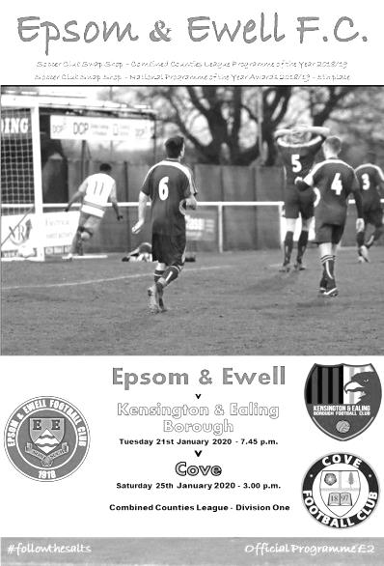
Salts freeze Borough out

What an excellent start to 2020! Two matches, two wins, two clean sheets, no bookings and up to twelfth place, surely now enabling us to start looking up at the table instead of down.

On a freezing night at High Road, both teams produced an entertaining and attacking display to warm the crowd. It's a pity that it numbered just twenty; our third worst home attendance in club history and lowest since 2008, when we were playing at Banstead Athletic. It doesn't help when there are Premier League matches on the television, yet many of the people sitting on their sofas watching it are the same ones whining about how VAR is killing the game. Not here, where you can actually watch your local team play with a bit of passion and I'm happy to report, a little bit of flair and organisation too.

It must be remembered that we secured just three clean sheets in the whole of 2019 and two of those came as late as December. Of our back four in this match, three are relatively new arrivals which has clearly helped and whilst Jahmahl King and Tariq Straker have been with us for a couple of months alongside long-serving Lloyd Connelly, a new right back Gideon Acheampong has added to the solidity, which was particularly useful against a team like Kensington who possess the threat from either flank of their leading scorer Walid Hirsi, who was kept quiet for most of the evening.

It wasn't a happy night for the visitors who encountered a fairly hostile M25 on their way over and arrived not long before kick off. They also had chances to take the lead, particularly in the seventh minute when Evia Batousol broke through on goal but in trying to guide the ball around Conor Young, he scuffed the ball straight at him. It would prove to be their best chance of the match and we took the lead in the 21st minute. Bobby Bennett ran at the defence before setting up the returning Jake Robinson. His shot was tipped onto the bar but as it fell, it rebounded off a defender straight back to Bennett who had continued his run and he knocked the ball in from close range.

We had just begun to get into our stride after that slow start and Bennett tried again with a low shot that took a slight deflection and was well held by the visiting keeper Hossah Hassan. Moments later Robinson played a great reverse pass into the path of Taryn Smith who set up Jordan-Boateng Anderson with a good opportunity but his shot was just wide of the post. It wasn't a memorable day for our new winger who required treatment for illness in the first half and failed to reappear for the second, being replaced by the returning Kieran Campbell.

The visitors sent a shot just over Young's goal on the half hour but we were still causing most of the damage and Bennett's low ball in rebounded off Smith to Robinson, but he dragged his shot wide from a good position. It looked like that miss could be costly as the final minutes of the half were a little frantic. The visitors pushed for an equaliser and a few panic clearances ensued, which just added to the pressure on us. However, we survived and wouldn't face so much heat in the second half.

The second period started positively with the increasingly influential Robinson linking well with Campbell in the 50th minute and getting his toe to the ball just ahead of a defender who upended him in the penalty area. He knew he was going to be caught and maybe made the most of his fall, but it was a clear penalty to everyone but the referee who waved appeals away. Even the Assistant said the decision was a bit harsh, while Hassan also agreed with me behind the goal that Borough had dodged a bullet there.

We nearly extended our lead four minutes later when a quick free kick was played to Straker on the left and his low ball into the near post was reached first by Smith eight yards out, but the contact wasn't quite firm enough and the ball just ran past the far post. Robinson was next to try at goal after intercepting a poor pass out of defence, although his shot from the edge of the box lacked composure and cleared the bar by some distance. We continued to attack and Smith's shot rebounded to Jacob Skelly, whose shot was a bit too close to Hassan and he made the save from 12 yards out.

It was all Epsom by this point and Campbell's swerving 25 yard strike was well parried by Hassan with Bennett being unable to take advantage of the rebound as it came at an awkward height to him and he knocked the ball wide. One-nil is never a comfortable lead and we had a scare when King ended a dangerous run from the visitors in an illegal fashion and I thought he would find his way into the book for his actions, but he escaped and the subsequent free kick from the edge of the area went straight into our wall and was cleared. However, an equaliser would have been harsh at this stage as we were well on top by this stage and at the other end Skelly was unfortunate to head an Acheampong cross onto the roof of the net. A few minutes later he would have more success when a ball over the top was controlled perfectly and he ran on to curl the ball beyond Hassan from 12 yards in the 86th minute and put the result beyond doubt.

In the final minute Young confirmed his eighteenth clean sheet for the club when he tipped a cross over his own bar, and the better team won on the night.

This was a fine performance. Against a British Airways team in transition we might have been expected to get the points, but against a viable top four contender in Kensington & Ealing Borough there was a much greater threat, which was in the end seen off fairly comfortably. We sit in twelfth place but are only one point away from ninth with two important home games coming up against Cove and Sandhurst in the next week. Let's hope that we are six points better off in a week's time and with a few more people present to see it.

Epsom and Ewell; Conor Young, Gideon Acheampong, Tariq Straker, Jacob Skelly,
Jahmahl King, Lloyd Connelly, Bobby Bennett, Scott Murphy (c), Taryn Smith,
Jake Robinson, Jordan-Boateng Anderson

Subs: Kieran Campbell for Anderson (HT), Tyrell Hallier-Degale for Bennett (90)

From behind the goal
Epsom & Ewell 4-0 Cove
Combined Counties League - Division One - Saturday 25th January 2020

Two becomes three as Salts get four

On Saturday our recent run of wins and clean sheets extended from two to three with a 4-0 victory over Cove at High Road. It should be pointed out that we already have more clean sheets in the League in 2020 than we registered in the whole of 2019 and our recent run of three wins without conceding is the first time we've done this since 2015!

As you might expect after our hard working victory over Kensington & Ealing Borough on Tuesday, there was only one change from the starting eleven as Daniel Duncanson made his debut on the left wing, while Jordan-Boateng Anderson who had struggled with illness in that match started on the bench but would have a major effect on proceedings later.

We started in a confident manner and started to press our visitors from the start, albeit with no actual shots on target. Cove had a half chance in the 18th minute when their left winger found space at the far post, but used his arm to control the ball and the free kick was awarded against him. Another long shot just whizzed past Conor Young's far post, but in the 25th minute we went ahead. Gideon Acheampong played the ball down the line to Bobby Bennett, who then interchanged passes with Taryn Smith who set him off down the right wing and his low ball across goal was finished off from six yards by Duncanson.

We did pick up our first booking of the New Year after Acheampong got involved in a minor scuffle with Chris Morris, which ended in a pair of yellow cards, but we continued to push our visitors back and a nice pass from Jake Robinson found Duncanson again, although his shot was high and wide this time. The youngster was making his senior debut after moving up from local football, but his battle with the experienced Cove Captain Aaron Parfitt was an interesting one and there is clearly more to come from Duncanson, who is only eighteen and although there are many younger players who have represented us in the past, he currently holds our record for being the most recently born player to wear our colours, having been born in October 2001, just to make most of our readers feel old!!

At the other end, Jahmahl King made his one error of an otherwise perfect day when his sliced pass was intercepted and then played through to a Cove attacker, but he recovered ground quickly to dispossess him and our back four would remain in control for the rest of the match. We responded by sending Duncanson away down the left and his cross was met by the head of Jacob Skelly who had made an untracked run into the penalty area, only to see his header well blocked at close range by Craig Atkinson in the visitors goal. Skelly was

well advanced again to receive a clever Scott Murphy pass but his dangerous cross was then headed away from Duncanson by Parfitt.

However, in the first minute of injury time, largely incurred for treatment for James Jupp who had been substituted by this point, we extended our lead. Smith played a superb reverse pass through to Bennett who ran in, rounded Atkinson and planted the ball into the net. There was a suspicion of offside about this goal, but Bennett had been making some great runs throughout the half and maybe this time he did beat the offside trap, but it did look to me, even from behind the goal that he had a bit of a head start on the defenders. No matter; some you win, some you lose and we were 2-0 up at the half.

Were we two goals better at the half? This was a topic that split opinions in the club house, but as always with a two goal lead, the opening minutes of the second half would be key, and they were bossed mainly by us as we hassled and harried our opponents, making them work for every inch of space and on many occasions they were forced to play long balls that just ran through to Young. Skelly was about a foot wide with a left footed shot that appeared to come with no back lift and had Atkinson struggling to get across, before Duncanson was next to attack and cut inside his man, although his subsequent shot was off target.

Skelly had to be alert at the back post to head a deep Cove delivery away for a corner and from the set piece, a shot on goal was blocked close to the line by Acheampong, and the danger was cleared. Anderson came on for the tiring Duncanson and our next attack came from Robinson, who was put down the left by a nice diagonal pass. his attempt at a cross was blocked back to him, although his shot then went over the bar with better options in the middle waiting.

We nearly got caught out from a short corner but Adam Aliston's shot was sliced well wide from the edge of the area and we made it 3-0 in the 88th minute when Anderson collected the ball on the left wing, then beat his man, ran in on goal and slid the ball under Atkinson at the near post. It was a great run and finish and as we took complete control of the match Smith was unfortunate to see his shot clear the bar by inches and when Skelly was upended on the edge of the box, Tariq Straker was also very close with the free kick, missing the frame of the goal by inches.

The final word went to Anderson in the 93rd minute when a ball in to Smith was held up and laid back for our substitute to smash the ball into the top corner from just inside the penalty area at an angle. It was a superb strike and put the seal on a fine win against a team that, it should be remembered, were above us in the table before this match. We are up to ninth place now and while further climbs are more challenging as many of the top sides also won this weekend, all you can do is keep going and see where it takes us. We still have many of those teams to play and one of these, Sandhurst Town are up next on Tuesday. Surely it is worth coming down to watch us right now?

Epsom and Ewell; Conor Young, Gideon Acheampong, Tariq Straker,
Jacob Skelly, Jahmahl King, Lloyd Connelly, Bobby Bennett, Scott Murphy (c), Taryn Smith, Jake Robinson, Daniel Duncanson

Subs: Jordan-Boateng Anderson for Duncanson (68),
Joe Bonass-Ward for Bennett (77), Steve Betancourt for Robinson (83)

From behind the goal
Epsom & Ewell 1-1 Sandhurst Town
Combined Counties League - Division One - Tuesday 28th January 2020

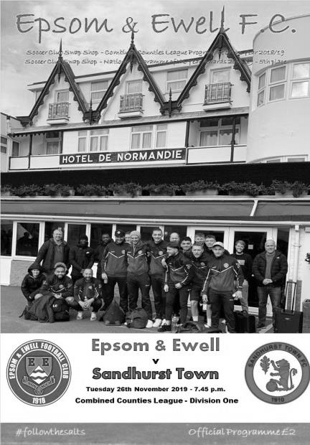
A well fought draw was a fair result

The new-look Salts eleven had their 100% start dented on Tuesday evening by a hard-working and committed Sandhurst Town team who held us to a 1-1 draw. We were well worth a point over the ninety minutes and did probably shade the battle in terms of chances created, but the visitors led until late in the match and arguably should have been playing against ten men as the referee failed to send off our keeper Conor Young in the second half for a foul outside of the penalty area.

If Young was fortunate to escape the red card on that occasion, he was equally unfortunate in the 38th minute when he was impeded for the visitors goal which was headed in from close range by Sam Green. This was our first goal conceded in 2020 and ended a run of 313 minutes without having to pick the ball out of our net and to say it was controversial is an accurate description!

But back to the start. We named a very similar squad to that of our recent matches and the starting eleven was identical to that which took the field seven days previously against Kensington & Ealing Borough. Against Cove three days previously, Daniel Duncanson had come in for Jordan-Boateng Anderson, but this time Anderson was back to start with our debutant scorer from the last match waiting to join the action from the bench.

We had an early concern when a right wing cross found a visiting striker at the far post, but he scuffed his contact and the ball dribbled through to Young. In response Bobby Bennett flashed a low cross along the Sandhurst six yard area but it was just too far ahead of the incoming Anderson. Young made a good save at the near post to keep out a powerful strike and in the 17th minute Bennett put Taryn Smith through and he set up Anderson who beat his man only to see his low shot across goal well kept out by the left foot of Matthew Watson in the Sandhurst goal.

It was a game of half-chances mostly as both teams covered a lot of ground which had the effect of them cancelling each other out for a while. We did have a really good opportunity on the half hour when a corner was only half cleared but then fed back in to Bennett, but he sliced his shot into the side netting as he attacked from an angle, and the ball became more of a threat to a cup of hot chocolate being held behind the goal by one of our supporters!

An even match swung the way of our visitors in the 38th minute, but arguably it happened

earlier. A minute or two before we conceded, Anderson was running at goal with Tariq Straker in a good overlapping position, but Anderson over ran the ball and the visitors broke at space, attacking the area that Straker had left and finishing with a decent save by Young for a corner. Although that was cleared out for another one, the second was more dangerous and although I am a long way off, it certainly looked as though Young tried and failed to connect with the ball. It was clear from player reactions as the ball ended up in the net that they felt our man had been fouled. Some rather erratic decisions by the referee were already beginning to confuse and frustrate both sides, although Straker went a bit too far and found himself consigned to the sin bin with a couple of seconds remaining in the half. We'd have to see out the opening ten minutes of the second half without him.

That ten minutes eventually became eleven as Young needed some treatment after being bundled over by Grant Kemp, who I felt should have received a yellow card for his challenge. Maybe this was on the referee's mind in the 54th minute when Danny Turner broke through on goal and as he rounded Young, he seemed to bounce off him and fell to the ground. He had just knocked the ball a bit wide before the contact and may have been looking for the foul, but the free kick was awarded and from that point you expect him to be walking, but instead he received a yellow card. I'll be honest, if it had happened the other way around, I'd have been extremely annoyed had the keeper stayed on the field.

Straker rejoined the action soon afterwards and Adam Heagney and Duncanson joined the fray for Jacob Skelly and Anderson as the game approached its final quarter. As you might expect from a team chasing the equaliser, we had a bit more of the play, but the visitors defended extremely well with Green and Luke Cox reaching everything and they were still dangerous on the break and we conceded a foul on the edge of the box on a Sandhurst counter attack in the 80th minute. Fortunately the ball was fired into the wall and the follow up struck wide.

And it was in the 84th minute that we levelled the scores. Duncanson fed the ball in which was half cleared to Smith. He beat his man on the left and drilled the ball across goal where Bennett was there inches ahead of a defender and stopped to make the first contact with his head from a couple of yards out, with the ball glancing the defender on its way in. Bennett has moved up our Hall of Fame top 50 scoring charts rapidly, in just two weeks since joining it he has risen to 42nd with his 37th goal for the club.

The visitors played the final few minutes of the match with ten men due to an injury to Cox and Kemp belatedly received the booking he should have received earlier in injury time, but despite the efforts of the referee, this was a superb match for the neutral and although both teams could have been better in possession, the reason they weren't was largely due to the work rate from both teams which closed down space wherever it existed. Did we deserve a point? Most definitely, although Sandhurst can quite justifiably look at the Young incident and wonder whether we'd have been able to force an equaliser with just ten men on the field. Instead the result ensured that at the eighteenth attempt, these two clubs produced their first ever draw.
Epsom and Ewell; Conor Young, Gideon Acheampong, Tariq Straker,
Jacob Skelly, Jahmahl King, Lloyd Connelly, Bobby Bennett, Scott Murphy (c), Taryn Smith, Jake Robinson, Jordan-Boateng Anderson

Subs: Adam Heagney for Skelly (59), Daniel Duncanson for Anderson (73)

This Day In History – 8th February
Date | Day | Competition |  | Opponents |  | Scorers
08/02/30 | Sat | London League | H | Bostall Heath | 5-1 | F.Watts (3), H.Barber, E.Parker
08/02/47 | Sat | London League | A | Crittall Athletic | 1-0 | R.Bostock
08/02/58 | Sat | Corinthian League | A | Edgware Town | 1-4 | V.Frost
08/02/64 | Sat | Athenian League 1 | H | Horsham | 1-3 | G.Whooley
08/02/69 | Sat | Athenian League 2 | A | Boreham Wood | 1-3 | D.Legrice
08/02/75 | Sat | F.A. Vase 5 | H | Hornchurch | 1-0 | P.Walker
08/02/92 | Sat | Isthmian League 3 | H | Eastbourne United | 2-0 | A.Webster, M.Pepper
08/02/94 | Tue | Surrey Senior Cup 1 | A | Egham Town | 1-2+ | T.Tweedy
08/02/97 | Sat | Isthmian League 3 | A | Kingsbury Town | 3-1 | S.Smith, A.Boxall (pen), S.Miller
08/02/03 | Sat | Isthmian League 1s | H | Carshalton Athletic | 1-4 | J.Hall
08/02/11 | Tue | Combined Counties Premier Division | H | Croydon | 3-2 | R.Bedj Bedj (2), B.Hayward
Historical Decades
90 years ago – Epsom Town F.C.
08/02/30 | Sat | London League | H | Bostall Heath | 5-1 | F.Watts (3), H.Barber, E.Parker
80 years ago – Epsom Town (wartime) F.C.
10/02/40 | Sat | Surrey Senior Cup 1 | H | Vickers Armstrong | 5-1 | W.Williams (3), B.Ruffell (2)
70 years ago – Epsom F.C.
11/02/50 | Sat | Corinthian League | H | Windsor & Eton | 2-1 | K.Minter, o.g.
60 years ago – Epsom F.C.
06/02/60 | Sat | Corinthian League | A | Letchworth | 2-3 | N.Dearlove (2)
50 years ago – Epsom & Ewell F.C.
07/02/70 | Sat | Athenian League 2 | A | Eastbourne | 0-0
40 years ago – Epsom & Ewell F.C.
09/02/80 | Sat | Isthmian League 1 | A | Hampton | 1-0 | K.Ellis
30 years ago – Epsom & Ewell F.C.
06/02/90 | Tue | Isthmian League 2s | A | Southall | 0-4
20 years ago – Epsom & Ewell F.C.
05/02/00 | Sat | Isthmian League 3 | A | Hertford Town | 0-0
10 years ago – Epsom & Ewell F.C.
09/02/10 | Tue | Combined Counties Premier Division | A | Dorking | 5-0 | K.Hough (3), R.Burns (2)
History Corner – 8th February
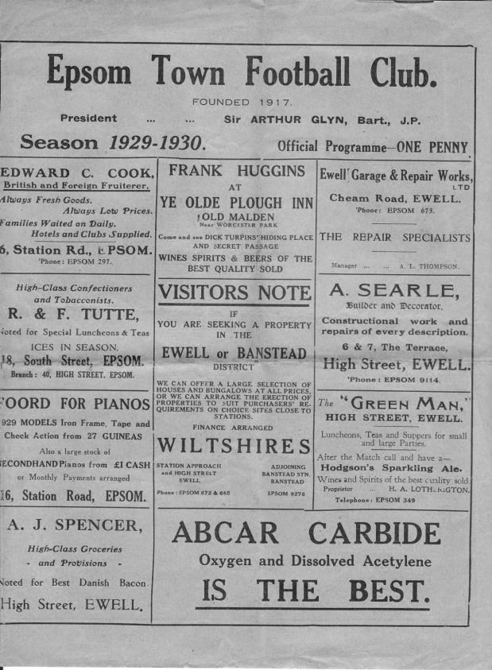
90 years ago today we hosted Bostall Heath in a London League match. Bostall Heath is an area of South London, not far from Blackheath and Welling and they had a decent football team back then. However, a hat trick from Fred Watts and goals from H.Barber and E.Parker consigned them to a rather heavy 5-1 defeat at West Street. (see programme pictured) In fact the local papers said the score flattered Epsom and a two-goal win would have been more accurate! Bostall Heath lost their Wickham Street ground to housing just before the war and folded in May 1939, not taking their place in the London League for the ill-fated 1939/40 season.

73 years ago today we travelled to Crittall Athletic’s Cressing Road ground and despite not being a great team that season, we handed them their first home defeat of the season with a 1-0 win. It was hard-earned. Keeper Harry Tiffany made a brave save early in the second half and lost five teeth in the process!! He carried on playing in bitterly cold conditions with snow underfoot and a Roy Bostock goal won the points. Later in the evening Tiffany was at a social function and the menu included turkey. The papers reported that he had "to look the other way"! Crittall Athletic went on to assume the name of their town, Braintree, and remain at Cressing Road to this day.

45 years ago today we were at home to Hornchurch in the Fifth Round of the F.A. Vase. The Essex team were warm favourites but a Phil Walker goal was the difference between the sides as we progressed to a home Quarter-Final with Addlestone. After the match, Secretary Stan Bailey took a phone call at the ground from someone asking for the score. Upon being told, the caller asked if Stan was sure, so surprised was he to hear that his team had lost. "Of course I am, after all I am the Epsom Secretary" came the reply!

26 years ago today we departed the Surrey Senior Cup at Egham Town. We had been behind for much of the match, but equalised through Tim Tweedy in the final minute to earn a period of extra time. Regrettably they scored in the first minute of that period and we lost 2-1, wondering whether it had been worthwhile to earn the extra period in the first place.

10 years ago this week Kyle Hough scored a hat trick as we destroyed Dorking at Meadowbank with five first half goals. It was Hough’s second consecutive hat trick and he became the first player to do this since Steve Hill in 1984. No one has done it since.

From behind the goal
FC Deportivo Galicia 2-3 Epsom & Ewell
Combined Counties League - Division One - Saturday 1st February 2020

Wild game at Bedfont ends with late twist

One of the strangest games of football seen for some time took place at the Bedfont Sports Club on Saturday and resulted in a narrow 3-2 win for our boys, thanks to a late Taryn Smith header. How late? Well, it came in the ninth minute of what would eventually become eleven extra minutes at the end of the match and was therefore probably the latest goal ever scored in an Epsom match.

There were huge celebrations after the goal and the final whistle, both on and off the pitch and I am guessing that they were mostly fuelled by relief as dropped points here would have been disastrous as this match should have been put to bed comfortably in the first half, but the second half was much more even so credit goes to our boys for continuing to work hard right to the final whistle.

This game had pretty much everything in it, starting with a late kick off. One of the Assistants was running late and there were no flags for them to use, so the game nearly kicked off at 3.15 with both Assistants carrying a brightly coloured soccer bib! Fortunately, flags were found just in time as was a replacement official as our fully qualified former Captain Alex McKay had come along to watch and ended up running the line for twenty minutes. There were memories of a similar incident back at Merstham in January of 2012 when one of our supporters, John Bonner, found himself in a similar position and John was in the crowd yesterday, probably suffering flashbacks!

We set off at breakneck speed and with a strong wind behind us and had the ball in the net twice inside ninety seconds, but Jake Robinson and then Jordan-Boateng Anderson saw their efforts disallowed. We nearly scored in the third minute when Bobby Bennett broke through on the right but he dragged his shot a little and it rebounded back into play off the far post where Robinson at full stretch was unable to keep the ball on target.

The hosts tried their luck from distance but the shot ran wide of Ben Ashton's goal. He was making his Salts debut as Conor Young was nursing a sore leg picked up in Tuesday's draw with Sandhurst Town. However, we were soon on the attack again and Bennett reached the ball ahead of the exposed keeper Dani Diaz on the right but his cross was cut out by a covering defender.

The chances continued to come and Anderson was clean through but took a really heavy touch at the wrong moment and the ball ran through to Diaz but the pattern of this match was of fairly total domination to this point. If there was a criticism it was that we failed to make much use of the wind advantage, over hitting many passes which just ran out for throws or goal kicks. I've no idea whether we won the toss of the coin for choice of ends, but the capless Diaz was also confronted with a bright setting sun in this period.

It came as a bit of a shock when we then conceded in the 25th minute. The ball made its way out to the right where a low ball in could have been knocked in by two or three of their players, but was finally finished off at the far post by Julian Lorenzo. Fortunately we were back on level terms in the 27th minute with a very strange goal. The ball was passed in to Bennett whose shot was well blocked from close range by Diaz, but the ball was still heading towards the goal and as the keeper ran back to retrieve it, Matt Sermon tried to clear the ball from under the posts, only to succeed in smashing the ball straight at Diaz and rebounding into the net for a proper comedy own goal!

We continued to press, although we had one lucky escape when Jahmahl King brought down a Deportivo Galicia player on the edge of the box. Fortunately the free kick was blazed over Ashton's bar and Leo Carballo then

wasted a good chance a minute later, lacking in composure when in a good position and his shot went wide.

Finally in the 42nd minute we had the lead and it was another curious goal. The ball was delivered into the six yard box where there was an almighty scramble. The returning James Fray was heavily involved and when he fell to the ground there were shouts for a penalty. Whether that delayed the defender into making a clearance, I don't know, but King got there just ahead of him to knock the ball goalwards at a fairly slow pace, only for Diaz to then let the ball dribble straight through his legs and into the net, allowing King to claim his first goal for the club as a result!

We nearly made it three-one when a Scott Murphy free kick was flicked on to Jacob Skelly beyond the far post where he produced a superb scissor volley which smacked off the Deportivo crossbar and away to safety. However, as time expired in the first half we switched off at the back and paid the price. Ashton made a fine save in injury time but the ball came back in moments later and Ansa Izologoun, waiting at the far post in a lot of space, drilled the ball past Ashton and into the roof of the net in the 48th minute.

It was hard to believe that we weren't ahead at half time, having also had the wind behind us and such a large amount of possession, but our opponents, fresh from a cup win over Fleet Spurs in midweek clearly took hope from the scoreline and the second half was to be more even. One thing that we saw a lot more of in the second half was some overlapping runs on the left from Tariq Straker and this would bear fruit later in the match, even if his first couple of deliveries were cut out.

Daniel Duncanson and Lloyd Connelly came on in the 55th minute as we tried to change things up as Bennett and Fray were withdrawn from the action, but this was becoming a frustrating afternoon. There were some inconsistent decisions in the second half, particularly with reference to the advantage law which was either not applied at all, or pulled back significantly later than it should have been. The game started to get niggly as the referee started to lose control a little, although it must be said that he got the major decisions right.

The hosts hit the post with a low shot, but in response Duncanson was set up by Murphy and exchanged passes with Robinson before Gideon Acheampong delivered a deep cross, but Smith was at full stretch and couldn't keep his header on target. Smith's next effort on goal was repelled by Diaz's legs before he dragged a shot wide from another good position as did Duncanson moments later. However, Smith's work rate was causing the opposition a lot of trouble and when Jacob Sewell came on for his debut after joining on loan from Chipstead, we started to look more dangerous. Additionally, Straker was able to get down the left a bit more due to the withdrawal of Anderson and in the 83rd minute he made a good run on the left only to see his powerful shot blocked by Diaz. The opposition were threatening still though and whilst a number of long shots didn't trouble Ashton we nearly conceded in the 92nd minute when a routine deep cross was headed onto our bar at full stretch. We then had a couple of scuffles, one of which was almost joined by their Manager who was half way across the pitch before being told to leave the field.

The defining moment of the match came in the 94th minute. Straker made another great run and burst through the defence clean through on goal. Or at least, he would have been, had he not been brought down right in the edge of the area by Oscar Ropars. After further delays he received a red card. Eventually we were ready to take the free kick and Murphy curled the ball expertly towards the top corner of the goal. With Diaz beaten, time seemed to stand still for a moment, only for the ball to clip the underside of the bar, drop down and bounce out. As claims followed that the ball had crossed the line, Smith reacted quickest to head the loose ball into the net from three yards out resulting in "scenes" towards the touchline as the players celebrated.

Did Murphy's original free kick cross the line? Apart from the keeper, I was probably the next nearest to the ball and it certainly seemed to bounce on the other side of the line, but as we have seen many times recently with goal line technology, it needs to be quite a way over before the whole ball is over the line and the Assistant hadn't indicated a goal so it was just as well that Smith settled any doubts or we could have been talking about this one for quite some time.

So finally after 101 minutes the game was over and our fine start to 2020 continues. However, we were mightily fortunate to pinch such a late winner and whilst it was good to see our boys working hard until the end, wasted chances and our first average defensive display of the year mean that we have much to do still if we are to put consistent pressure on the teams above us, as previous points dropped mean that there is no further margin for error as we attempt to close the gap on them.

Epsom and Ewell; Ben Ashton, Gideon Acheampong, Tariq Straker, James Fray, Jahmahl King, Jacob Skelly, Bobby Bennett, Scott Murphy (c), Taryn Smith, Jake Robinson, Jordan-Boateng Anderson

Subs: Lloyd Connelly for Fray (55), Daniel Duncanson for Bennett (55), Jacob Sewell for Anderson (78)

From behind the goal
Epsom & Ewell 3-0 Nottsborough
Surrey Premier Cup – Second Round - Tuesday 4th February 2020

Best for many months as Salts progress handsomely
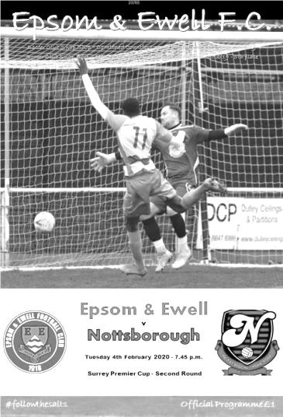
Going into this match, it was clear that it would require an excellent performance to defeat high-flying Southern Amateur League Nottsborough. Twice winners of the Surrey Premier Cup in the previous four seasons and also last year's narrowly defeated finalists, they represented a huge obstacle for our boys. Yet after an even first half we simply swatted them aside in the second and once Jake Robinson had struck a stunning opener from distance there only looked like being one winner.

The Surrey Premier Cup is an unusual competition. Unlike the Senior Cup it is filled with Development sides, Reserve teams, Amateur League sides and a sprinkling of teams from our own Division and another low attendance welcomed the players once again. However, the 27 who attended were treated to a superb display, particularly in the second half which hasn't been bettered since that famous day in August 2016 when we scored nine in the second period at Bedfont & Feltham.

In terms of personnel Lloyd Connelly returned to the starting line up at the back, while Adam Heagney came in for the absent James Fray. These were the only changes to the eleven which defeated FC Deportivo Galicia so narrowly on Saturday, but this performance would provide much more in the way of consistent good play, even after we lost Jahmahl King to a nasty facial injury at half time following a clash of heads that occurred just before the break. We hope he will be able to play again soon.

The opening exchanges were even, although the ball spent more time in our half than that of our visitors. Still, there was little of concern for either keeper to deal with until the first real chance of the match came along in the 19th minute when a nice pass to Bobby Bennett left him through on goal in the right hand channel, but he went for power and dragged his shot tamely beyond the posts. On the half hour Taryn Smith was fouled right on the edge of the area in the act of shooting, and I'll be honest, I thought Scott Murphy would take the kick, having been so accurate on Saturday. However it was the left footed Tariq Straker that curled the ball over the wall and it pinged off the Nottsborough crossbar and out for a goal kick, having done so well to get the ball up and down again from such a short distance.

We started to find some gaps in the opposition's defence and a low ball in from Bennett found Jordan-Boateng Anderson, although his contact was not the greatest and Ben Lancaster in the Nottsborough goal had an easy save to make. I thought it might cost us when they then had their best chance of the half as a ball was played over the top of our back four, where their player had a shot on goal from close range well blocked by Ben Ashton. However, we were beginning to threaten more and Taryn Smith probably should have done better when a deep free kick eluded everyone else and found him just beyond the far post, but he blazed the shot over the bar from

just four yards out. In mitigation, it was a difficult angle.

Bennett scuffed his shot after a good run on the right hand side by Straker after we had retrieved a half cleared corner, before Bennett found Anderson in a good position, but his goalbound shot was superbly saved by Lancaster to keep the score level at the break.

King's 43rd minute injury required Jacob Skelly to come in at the back as the second half commenced and what a half it would prove to be. We nearly scored in the opening minute after Straker had made another great run on the left, but his cross was too firm and eluded everyone. Then on the right Gideon Acheampong won the ball and found Bennett whose cross to Smith was cut out at the last minute by a defender. We had a scare at the other end after a wayward pass from Connelly nearly saw us concede from our own corner, but Ashton made the save and we continued to press with Bennett's low cross punched away by Lancaster and Murphy's attempt from twenty yards not having enough on it to trouble Lancaster. All of this in just the opening ten minutes!

We finally broke through in the 55th minute. Bennett was fouled right out on the touchline near the corner flag and everyone gathered in the area for the free kick. However, Straker played the ball back to Jake Robinson, just over thirty yards out in the middle of the park and his stunning strike flew in off Lancaster's right hand post, just inches below the cross bar. It was an unstoppable effort and the celebrations told their own story. We continued to press and Bennett saw his swerving effort parried for a corner by Lancaster with Heagney heading the subsequent corner wide at the far post.

In the 65th minute Smith was unlucky when two Nottsborough defenders went to clear a Murphy free kick and the ball fell to him. He flicked the ball over a defender but his left footed strike missed the far post by inches. However, the second goal arrived in the 72nd minute when a short corner to Straker resulted in a deep delivery to Skelly at the far post who headed back across goal for Murphy to turn the ball in from a couple of yards out. Two became three just five minutes later as we stretched the visitors down our right wing, before sending the ball in to Robinson standing centrally. He then fed the ball across to Straker who struck the ball on the turn across Lancaster and into the bottom corner from just inside the box.

At 3-0 the match was clearly over but we kept pushing. Jacob Sewell, on for Anderson just before the second goal, set up Bennett in a good position but his shot missed the corner of the goal by a couple of feet. Sewell also showed glimpses of his potential when he is fully fit again with a good run and low shot which was well saved by Lancaster's right foot. As the game entered its final minutes the visitors pushed for a consolation. Murphy picked up a yellow card for a mistimed challenge on the edge of the box, although the free kick came to nothing. Then three minutes from time a long range strike pinged off Ashton's crossbar and away. However, Ashton would not be denied his clean sheet and a fine save at the foot of his right hand post in the dying moments was sufficient to confirm it.

This was a fine performance and earns us a trip to Dorking Wanderers Reserves in the Quarter-Final. We still have to visit Meadowbank in the League this season, but without getting ahead of ourselves, if we keep this sort of form up we have every chance of making a third visit there for a Surrey Premier Cup Final too. Maybe it's time for a few more supporters to come along and watch, as for the first time in quite a while I can now say that I support a good team!

Epsom and Ewell; Ben Ashton, Gideon Acheampong, Tariq Straker, Adam Heagney,
Jahmahl King, Lloyd Connelly, Bobby Bennett, Scott Murphy (c), Taryn Smith, Jake Robinson,
Jordan-Boateng Anderson

Subs: Jacob Skelly for King (46), Jacob Sewell for Anderson (69),
Daniel Duncanson for Bennett (80)

Centre page for results

Centre page for results

EL Records Premier Challenge Cup
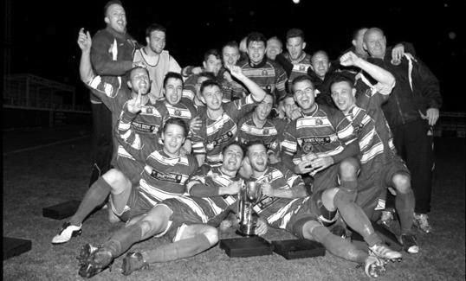
First Round
Guildford City | 2-3 | Hanworth Villa
Eversley & California | 2-4 | Balham
Tooting Bec | 2-4 | Bedfont & Feltham
FC Deportivo Galicia | 2-9 | AFC Hayes
Badshot Lea | 3-1 | Redhill
Colliers Wood United | 4-2 | British Airways
Egham Town | 0-2 | Raynes Park Vale
Spelthorne Sports | 6-2 | Chessington & Hook United
Godalming Town | 0-4 | CB Hounslow United
Second Round
Ash United | 2-2 - 4-1p | Bagshot
Westside | 2-1 | Southall
Hanworth Villa | 2-3 | Jersey Bulls
Abbey Rangers | 1-0 | Raynes Park Vale
CB Hounslow United | 3-4 | Balham
Camberley Town | 2-1 | Colliers Wood United
Bedfont & Feltham | 1-5 | Knaphill
Knaphill played an ineligible player – Bedfont & Feltham reinstated
Frimley Green | 3-7 | Ascot United
Sutton Common Rovers | 12/2 | Spelthorne Sports
Sandhurst Town | 2-1 | Cove
Banstead Athletic | 0-1 | AFC Hayes
Molesey | 3-1 | Kensington & Ealing Borough
Cobham | 2-4 | Fleet Spurs
Badshot Lea | 0-2 | Dorking Wanderers Reserves
Sheerwater | 4-2 | Epsom & Ewell
Farnham Town | 3-0 | Walton & Hersham
Second Round
Sandhurst Town | 11/2 | Dorking Wanderers Reserves
AFC Hayes | 18/2 | Sheerwater
Camberley Town | 11/2 | Farnham Town
Jersey Bulls | 3-1 | Fleet Spurs
Abbey Rangers | 18/2 | Bedfont & Feltham
Balham | 1-2 | Ascot United
Molesey | V | SCR / Spelthorne Sports
Ash United | 2-1+ | Westside

Ash United – History
Ash United Football Club was founded in 1911 and started playing their first competitive matches at Ash Common. They soon became well established in the Surrey Intermediate League, winning every honour possible. After the Second World War Ash United restructured and the 1947/48 season was the most successful in their short history, winning the League Championship and four-cup competitions.

They then had to wait until the 1966/67 season for their next successful campaign where they dominated the Surrey Intermediate Premier "A" League. The title was won with only two points dropped out of a possible fifty-two. This included a long unbeaten record with 121 goals for and only 19 against. The reserve team followed suit winning the Division "A" title scoring 137 goals in only 26 games. With the club having a strong squad of players, promotion to the Surrey Senior League was achieved in 1968. Finishing runners up in both the league and the cup in the first season their first spell in the Surrey Senior League came to an end in 1971 when being forced to change grounds. Ash United were re-admitted to the Surrey Senior League when a new permanent ground was found, which happens to be their current ground at Shawfield Road.

The next successful season was 1977/78. They won the Charity Cup beating Dorking 2-1. The following season they were runners-up in both the newly named Combined Counties League and the Philips Football Floodlighting Cup Competition. Several seasons later, 1981/82, not only did they win the Combined Counties League, but also came runners up in the Concours Trophy and the George Allen. The 1984/85 season they were runners-up in the Concours Trophy again, but also made it through to the quarterfinals of the Surrey Senior Cup. The 1986/87 season saw Ash United win the League for the second time under the management of Chris Penny.

In the 1996/1997 season improvements in the facilities at Shawfield Road were made, most notably the installation of floodlights, improvements to the changing rooms, dugouts, and fencing. Subsequent seasons saw the installation of the stands. The 1997/98 season saw a revival in Ash’s fortunes under the new player/ manager Jamie Horton with his new squad of players that won the Challenge Cup and the Fair Play Trophy in his first season. His team also created a new league and club record with 29 games unbeaten in league and cup, which included a run of 21 straight wins. The following season not only did they win the League title by a massive 13 points but also won the Aldershot Senior

Cup beating Fleet Town and reached the last 32 of the FA Vase losing to the Holders & winners Tiverton Town in front of a record crowd at Shawfield Road. Jamie briefly left and then came back for a second stint as manager. During the 2001/2002 season Ash United gained their highest points total for a season, 100, but they finished runners-up to AFC Wallingford. They did, however, regain the Aldershot Senior Cup beating 3 RSME Regiment, also reaching the last 32 of the FA Vase before losing to Tow Law Town.

League performances between 2002 and 2012 saw the club remain broadly mid table, apart from two good seasons when a 3rd and a 4th place was achieved. During the same period there were some good performances in both the FA Cup and the FA Vase. In 2012/13 however, the club’s fortunes took a turn for the worse and they ended up second-to-bottom but staved off relegation. Regrettably a similar placing the next season saw Ash United drop into Division One. It was the first time the club had been out of the Premier Division for a considerable number of years.

Rebuilding the first team began from season 2013/14, however, the club struggled to improve on mid- table finishes. Until last season, 2018/19, when Ash United achieved a 7th place, hitting 82 league goals – a tally not seen for over 12 years. Goals against was narrowed down to 66, a big improvement on the previous season, which had only been bettered once in the previous 12 years.

During 2017/18, Sam Wilson was appointed Head Coach, with Colin McCormack as Coach and Physio, Harry Broad as first team Coach and Ryan Weeks as Goalkeeping Coach. Sam Wilson also saw out the season additionally as U18 manager, assisted by George Kennedy and Rob Collins. The club also followed up winning the Division One Fair Play Trophy in 2016/17, with Runners-Up in season 2017/18 and winning Best Matchday Programme for Division One. The U18's won the Allied Counties South Division, with leading scorer, Jake Wilson, getting the Division's "Golden Boot". The U17's under the guidance of Manager Stuart Warren, won the Surrey Primary League's U17 Premier Elite Division.

For the season 2018/2019 Sam Wilson was appointed 1st team manager assisted by Colin McCormack and Kieran Evans. Ryan Weeks took over as Reserve team manager, assisted by Tom Waldron and the Under 18’s were managed by Stuart Warren, assisted by Malcolm Hughes.

For the 2019/2020 season, Sam Wilson remains 1st team manager, assisted by James Whitehouse. Harry Broad returns to take over as manager of the reserve team, with Ollie Hooker as coach. Adam Streeter is our Under 18’s manager.

Player Sponsorship
Here is the latest list for 2019/20, with new photos showing all of our players and Management that are available for sponsorship. Thanks, as always goes to our Club Photographer Gemma Jarman.

Sponsorship costs just £40 and it is easy to do. Just select a player who has not been previously sponsored and let a Committee Member know that you would like to sponsor them. Beware though. Until we have received the money it is possible for someone to jump in front of you, so don’t delay, sponsor today!

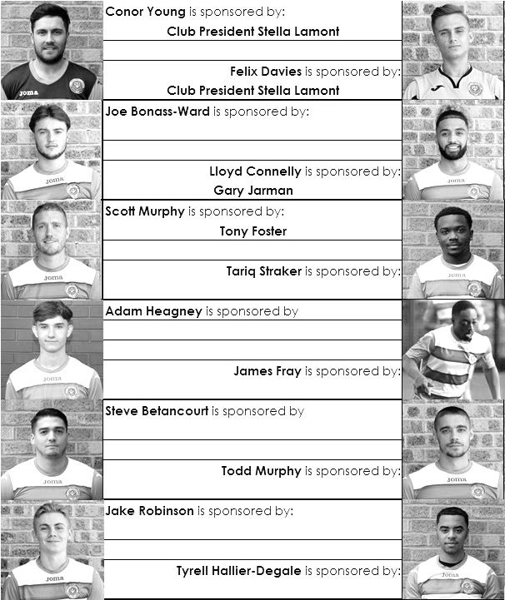

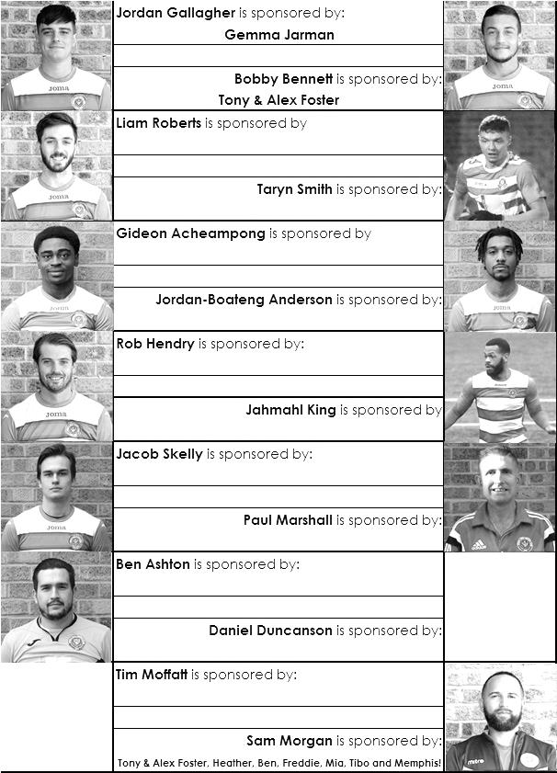

EL Records Division One Challenge Cup Draw
First Round
Kensington & Ealing Borough | 3-2 | Tooting Bec
Ash United | 1-5 | British Airways
Bedfont & Feltham | 3-1 | Epsom & Ewell
Bagshot | 1-4 | Walton & Hersham
Second Round
Dorking Wanderers Reserves | 2-3 | Jersey Bulls
Sandhurst Town | 4-1 | Chessington & Hook United
British Airways | 0-3 | Bedfont & Feltham
Godalming Town | 5-2 | Farnham Town
Cove | 1-1 p2-4 | FC Deportivo Galicia
Fleet Spurs | 3-1 | Westside
Walton & Hersham | 1-0 | AFC Hayes
Kensington & Ealing Borough | V | Eversley & California
Quarter-Finals
FC Deportivo Galicia | 3-1 | Fleet Spurs
Sandhurst Town | V | Kensington & Ealing Borough / Eversley & California
Godalming Town | 11/2 | Jersey Bulls
Walton & Hersham | 4-2 | Bedfont & Feltham

Our Club Statistical History - (inc Tuesday 4th February):
All League: Played: 2,981, Won: 1,221, Drawn: 567, Lost: 1,193
For: 5,488, Against: 5,308, GD: + 180 - Win Ratio 40.96%

Combined Counties League: Played: 559, Won: 247, Drawn: 108, Lost: 204
For: 1,022, Against: 922, GD: + 100 - Win Ratio 44.19%

Cup and Other: Played: 1,135, Won: 538, Drawn: 130, Lost: 459
For: 2,468, Against: 2,125, GD: + 343 - Win Ratio 47.40%

Abandoned Matches: Played: 8: For: 14, Against: 16

Under Sam Morgan: Played 6, Won: 5, Drawn: 1, Lost: 0
For: 16, Against: 3, GD: + 13 - Win Ratio 83.33%

Overall: Played 4,116, Won: 1,759, Drawn: 697, Lost: 1,652, Abandoned: 8
For: 7,956, Against: 7,433, GD: + 520 - Win Ratio 42.74%

For the purposes of these records, all matches that resulted in penalty shoot outs are recorded as draws, regardless of whether they were won or lost.

CCL Division One Club Directory
AFC HAYES: Telephone: 0208 845 0110 - Colours: Blue and White Stripes/Blue/Blue
Ground: Farm Park, Kingshill Avenue, Hayes, Middx. UB4 8DD

ASH UNITED: Telephone: 01252 344264 - Colours: Green with Red Trim/Green/Green
Ground: Shawfields Stadium, Youngs Drive, Shawfields Road, Ash, Aldershot. GU12 6RE

BAGSHOT: Telephone: 01252 623804 - Colours: Yellow/Black/Black
Ground: Camberley Town FC – Krooner Park, Wilton Road, Camberley. GU15 2QW

BEDFONT & FELTHAM: Telephone: 0208-890 7264 - Colours: Yellow/Blue/Blue
Ground: The Orchard, Hatton Road, Bedfont. TW14 9QT

BRITISH AIRWAYS: Telephone: 0208-890 7264 - Colours: Sky Blue/Navy Blue/Navy Blue
Ground: Bedfont & Feltham FC - The Orchard, Hatton Road, Bedfont. TW14 9QT

CHESSINGTON & HOOK UNITED: Telephone: 01372-602263 Colours: All Blue
Ground: Chalky Lane, Chessington. KT9 2NF

COVE: Telephone: 01252 543615 Colours: Yellow/Black/Black
Ground: Oak Farm, Squirrel Lane, Cove GU14 8PB

DORKING WANDERERS RES Telephone: 01306 400151 - Colours: Red & White Stripes/ Blue/ Red
Ground: Meadowbank Stadium, Mill Lane, Dorking. RH4 1DX

EPSOM & EWELL Telephone: 01737-553250
Colours: Royal Blue & White Hoops/Royal Blue/Royal Blue
Ground: Chipstead FC, High Road, Chipstead. CR5 3SF

EVERSLEY & CALIFORNIA Telephone: 0118 973 2400 - Colours: - White & Royal Blue Hoops /Royal Blue/ Royal Blue - Ground: Fox Lane, off Reading Road, Eversley. RG27 0NS

FARNHAM TOWN Telephone: 01252 715305 - Colours: - Claret & Sky Blue /White/ Claret & Blue
Ground: Memorial Ground, Babbs Mead, West Street, Farnham. GU9 7DY

FC DEPORTIVO GALICIA Telephone: 0208 831 9067 - Colours: Royal Blue/Royal Blue/White
Ground: Bedfont Sports FC - Bedfont Sports Club, Hatton Road, Bedfont. TW14 9JR

FLEET SPURS Telephone: 01252 662810 - Colours: Dark Blue with Red Trim/Dark Blue/Dark Blue
Ground: Kennels Lane Farnborough. GU14 0ST

GODALMING TOWN Telephone: 01483 417520 - Colours: Yellow/Green/Yellow
Ground: Wey Court, Meadrow, Godalming. GU7 3JE

JERSEY BULLS Telephone: 01534 449615 - Colours: Red and White
Ground: Springfield Stadium, Janvrin Road, St Helier, Jersey. JE2 4LF

KENSINGTON & EALING BOROUGH Telephone: 01372 360151 - Colours: All Blue
Ground: Leatherhead FC – Fetcham Grove, Guildford Road, Leatherhead. KT22 9AS

SANDHURST TOWN Telephone: 01252 878768 - Colours: Red & Black Stripes/Black/Black
Ground: Bottom Meadow, Sandhurst Memorial Park, Yorktown Road, Sandhurst. GU47 9BJ

TOOTING BEC Telephone: tba - Colours: Black & White Stripes/White/White & Black
Ground: Tooting & Mitcham United FC - Imperial Fields, Bishopsford Road, Morden, Surrey SM4 6BF

WALTON & HERSHAM Telephone: 07969 068731 - Colours: All Red
Ground: Elmbridge Excel Sports Hub, Waterside Drive, Walton-on-Thames. KT12 2JP

WESTSIDE Telephone: 01372-602263 - Colours: Yellow/Blue/Blue
Ground: Chessington & Hook United - Chalky Lane, Chessington. KT9 2NF

Results Grid
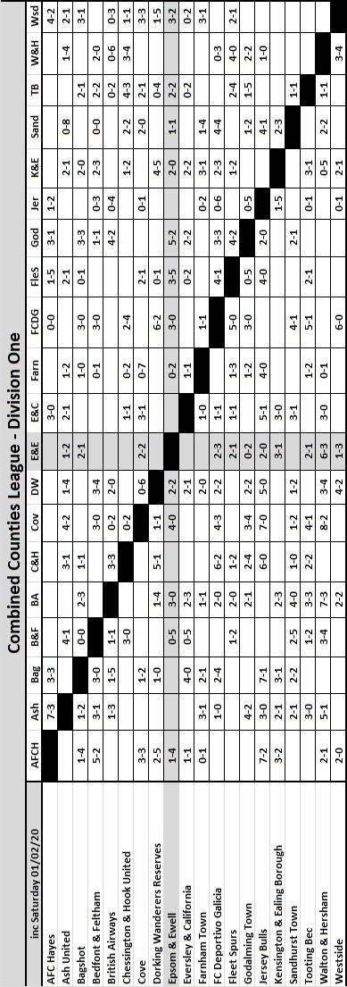

Combined Counties League Division One
Opponents All-time Records
inc 4th February 2020 | P | W | D | L | F | A | PPG | GD | Best  Win | Worst  Loss
Westside | 2 | 2 | 0 | 0 | 6 | 3 | 3.00 | +3 | 3-1 | -
Godalming Town | 8 | 7 | 0 | 1 | 22 | 11 | 2.63 | +11 | 5-1 | 0-3
FC Deportivo Galicia | 5 | 4 | 0 | 1 | 13 | 5 | 2.40 | +8 | 3-0 | 0-2
Bagshot | 4 | 3 | 0 | 1 | 12 | 3 | 2.25 | +9 | 7-1 | 1-2
British Airways | 3 | 2 | 0 | 1 | 8 | 5 | 2.00 | +3 | 3-0 | 2-3
Bedfont & Feltham | 7 | 4 | 1 | 2 | 26 | 20 | 1.85 | +6 | 9-2 | 0-5
Ash United | 22 | 12 | 4 | 6 | 52 | 33 | 1.82 | +19 | 6-0 | 0-3
Cove | 38 | 18 | 10 | 10 | 86 | 60 | 1.68 | +26 | 7-0 | 1-6
Chessington & Hook | 30 | 13 | 9 | 8 | 63 | 45 | 1.60 | +18 | 6-0 | 1-3
Walton & Hersham | 55 | 25 | 11 | 19 | 108 | 111 | 1.56 | -3 | 8-0 | 0-8
Farnham Town | 20 | 9 | 4 | 7 | 32 | 33 | 1.55 | -1 | 3-0 | 1-4
Eversley & California | 2 | 1 | 0 | 1 | 2 | 2 | 1.50 | 0 | 1-0 | 1-2
Dorking Wanderers Res | 3 | 1 | 1 | 1 | 8 | 7 | 1.33 | +1 | 3-0 | 3-5
Sandhurst Town | 18 | 7 | 1 | 10 | 30 | 32 | 1.22 | -2 | 4-0 | 1-3
Tooting Bec | 4 | 1 | 1 | 2 | 7 | 9 | 1.00 | -1 | 3-1 | 1-4
Fleet Spurs | 4 | 1 | 1 | 2 | 8 | 10 | 1.00 | -2 | 3-2 | 3-5
Kensington & Ealing Borough | 4 | 1 | 1 | 2 | 5 | 9 | 1.00 | -4 | 2-0 | 1-5
AFC Hayes  (inc Brook House) | 13 | 2 | 4 | 7 | 19 | 24 | 0.77 | -5 | 7-0 | 1-4
Jersey Bulls | 1 | 0 | 0 | 1 | 0 | 2 | 0.00 | -2 | - | 0-2

Our League neighbours!
Surrey Elite League
incl Saturday 1st February | P | W | D | L | F | A | Pts | GD
NPL | 17 | 11 | 1 | 5 | 52 | 28 | 34 | +24
AFC Cubo | 17 | 10 | 4 | 3 | 40 | 19 | 34 | +21
Battersea Ironsides | 16 | 8 | 6 | 2 | 40 | 22 | 30 | +18
Lyne | 18 | 8 | 3 | 7 | 31 | 42 | 27 | -11
Worcester Park | 12 | 8 | 1 | 3 | 26 | 14 | 25 | +12
Spartans Youth | 17 | 7 | 4 | 6 | 34 | 34 | 25 | 0
Royal Holloway Old Boys | 18 | 6 | 5 | 7 | 27 | 37 | 23 | -10
Horsley | 14 | 7 | 1 | 6 | 32 | 26 | 22 | +6
Old Rutlishians | 15 | 5 | 5 | 5 | 29 | 32 | 20 | -3
Staines Lammas | 15 | 5 | 4 | 6 | 30 | 29 | 19 | +1
Merrow | 15 | 3 | 4 | 8 | 24 | 30 | 13 | -6
Chessington KC | 14 | 2 | 7 | 5 | 23 | 32 | 13 | -9
Ripley Village | 11 | 2 | 3 | 6 | 14 | 24 | 9 | -10
AFC Spelthorne Sports | 12 | 2 | 3 | 7 | 17 | 32 | 9 | -15
Farleigh Rovers | 15 | 1 | 5 | 9 | 17 | 35 | 8 | -18
The Surrey Elite League may not be the League directly below Ash United, but they are definitely the League below us, so apologies to our visitors if this page isn’t much use to them!

The usual promotion rules state that any club in the top five can be eligible for promotion assuming the ground grading is sufficient for Step Six, which usually means having floodlights is the main challenge. We saw Westside come up from fourth place last year and clearly it is easier if you are ground sharing, at least in the short term.

Last season’s Champions AFC Cubo are thereabouts again, battling away with Kingston based NPL, but as far as I am aware their ground is not suitable, nor is Battersea’s. One club that is making a lot of positive noise right now is Lyne FC. Based in Addlestone, not far away from Abbey Rangers and even closer to the M25, they appear to be the team to watch, even if there is no way they will win the league while they continue to hold such a severe goal difference which also threatens their hopes of a top five position in the first place. Maybe next year?

Worcester Park are of course in the hunt for that title with many games in hand, but as we know, they aren’t coming back up unless they choose to ground share, which seems pointless while their facilities at Green Lane are very nice. Staines Lammas have now found their level and are back in the village league, but Farleigh Rovers, recent former Step Six Champions, are facing a real threat of further relegation. We obviously destroyed them 10-2 in a pre-season friendly back in July and they were really poor then, clearly little has changed there, which is very sad.

Ultimately the constitution of this division looks like remaining the same for some time. Despite the allowance this year for promotion of more than one club, it looks increasingly likely that there will be none at all!

Combined Counties League - Premier Division Table
incl Saturday 1st February | P | W | D | L | F | A | Pts | GD
Ascot United | 25 | 16 | 2 | 7 | 49 | 30 | 50 | +19
Spelthorne Sports | 25 | 15 | 4 | 6 | 48 | 31 | 49 | +17
Southall | 25 | 13 | 8 | 4 | 49 | 26 | 47 | +23
Molesey | 26 | 16 | 2 | 8 | 45 | 28 | 47+ | +17
Knaphill | 24 | 12 | 7 | 5 | 49 | 26 | 43 | +23
Frimley Green | 25 | 12 | 7 | 6 | 48 | 42 | 43 | +6
Abbey Rangers | 24 | 10 | 7 | 7 | 37 | 24 | 37 | +13
Egham Town | 27 | 11 | 4 | 12 | 51 | 52 | 37 | -1
Sutton Common Rovers | 22 | 11 | 3 | 8 | 54 | 36 | 36 | +18
Cobham | 25 | 11 | 3 | 11 | 32 | 31 | 36 | +1
Balham | 23 | 11 | 2 | 10 | 51 | 44 | 35 | +7
Colliers Wood United | 22 | 10 | 5 | 7 | 37 | 33 | 35 | +4
Badshot Lea | 24 | 10 | 2 | 12 | 45 | 41 | 32 | +4
Guildford City | 26 | 8 | 4 | 14 | 24 | 36 | 28 | -12
Redhill | 21 | 9 | 0 | 12 | 31 | 38 | 27 | -7
Camberley Town | 24 | 8 | 3 | 13 | 27 | 49 | 27 | -22
Sheerwater | 25 | 7 | 4 | 14 | 41 | 61 | 25 | -20
Banstead Athletic | 23 | 7 | 4 | 12 | 26 | 45 | 24^ | -19
Raynes Park Vale | 21 | 6 | 5 | 10 | 29 | 36 | 23 | -7
Hanworth Villa | 24 | 4 | 6 | 14 | 27 | 46 | 18 | -19
CB Hounslow United | 27 | 3 | 6 | 18 | 26 | 71 | 15 | -45
^ Banstead Athletic one point deducted --- + Molesey three points deducted
Many of you will already be aware that four clubs are to be promoted from Step Six this season, but there are also extra spots at Step Five due to the creation of an eighth Step Four League and to complete the F.A. reorganisation into a 1-2-4-8-16-17 pyramid this summer. As a result, the Champions will go up, as will the best four runners up (points per game) out of the Southernmost eleven Step Five Leagues and the other seven will face a playoff against the clubs finishing bottom of the seven Step Four Leagues. Just for information, the other three northern Step Five League will each promote their top three in an attempt to balance the North/South divide a little better.

So in short, if you finish second in this League, you will either go up or face a play off.

At the bottom, only one club can be relegated this season, but even then there could be reprieves, all based on points per game. To add to the confusion, the Combined Counties League are going to operate a second Step Five Division from next season, running a North and a South division and heading towards the Thames Valley and South Hertfordshire area. Obviously they are no longer running a Step Six League in our area, moving Westwards. This leaves us heading to either Sussex or Kent next season unless we can somehow pinch a top four position, but I digress!

Looking at the table, there is a very tight group of teams battling it out. Ascot United just hold the edge from Spelthorne Sports but any club down as far as Colliers Wood United are not out of the hunt yet, although only Sutton Common Rovers and Abbey Rangers are likely to join the top six in my opinion. I’m also unsure what ground grading requirements are being applied this season after a couple of seasons where they were relaxed. On that subject, Raynes Park Vale must be concerned as they are again suffering floodlight issues and last time I looked, to remain in Step Six you actually need working lights, not just some pylons standing there!

Assuming that there is no forced relegation for Raynes Park, CB Hounslow clearly have a lot of work to do still and they currently prove that a new ground doesn’t guarantee you success.

Epsom & Ewell FC Club History
We were founded in March 1918 as Epsom Juniors Cricket Club and played throughout the summer. In the autumn, Epsom Juniors F.C. came into being and played a handful of games from what is now known as Alexandra Recreation Ground. Competitive football followed as we entered the Surrey Junior League in 1919, and became founder members of the Sutton & District League in 1920.

A change of name in July 1922 to Epsom Town F.C. heralded the start of a very successful era. By now resident at the Horton Hospital Sports Ground, we were unfortunate to lose 2-1 after extra time at Dorking F.C.’s Pixham Lane ground to Caterham Mental Hospital in a replay of the Surrey Junior Cup Final. However, we won three other trophies that season, the Leatherhead Hospital Shield, the Sutton Hospital Cup, and the Epsom Hospital Cup. In addition, we also won the Sutton & District League, and under the forward thinking of their visionary Chairman Hugh Bradley, took the step into Intermediate Football, where we won the Southern Suburban League without losing a match. Senior football was granted as we were unanimously accepted into the Surrey Senior League for 1924/25, where we finished third.

In September 1925, the club relocated to the old Ewell F.C. ground at West Street, which was purchased through the generosity of our future President Robert Bradshaw. In 1925/26 the Championship of the Surrey Senior League was attained, and the following season, we defeated Egham 1-0 at Egham in the League Charity Cup to complete a League and Cup “double”. Election to the London League followed, and the title was claimed in the first attempt in 1927/28. Unfortunately, we were unable to repeat this, instead finishing runners-up in 1931/32, 1932/33, 1934/35, 1936/37 and 1937/38. Cup Honours were limited, although in 1929 Redhill defeated us 3-2 in front of 4,600 at Guildford in our first Surrey Senior Cup Final, having seen off Wimbledon 4-1 in the semi-final!

The thirties were a very successful era, and we won the Surrey Charity (Senior) Shield in 1933 with an impressive 5-0 win over Woking at Kingfield. However, the proudest moment of our pre-war history was an appearance in the First Round Proper of the F.A.Cup in 1933/34. Woking (after a replay), Nunhead, Tooting & Mitcham, Beddington Corner, and Leytonstone were defeated, and a crowd of 9,485 at the Lea Bridge Speedway Stadium witnessed a 4-2 loss against the hosts Clapton Orient. At the end of that season we changed names to Epsom F.C.

In 1939 a newly formed team, Epsom Town (no connection to the earlier name) shared the ground with Epsom F.C. However, this arrangement was suspended when war was declared, and we folded for the duration. In the meantime, Club Chairman Charles Pettett threw in his lot with Epsom Town in an attempt to boost morale by keeping the football flag flying. It was successful, as that club competed continuously throughout the war years, winning the Surrey Combination in 1939/40, and reaching the Surrey Senior Cup Final in 1944, losing 3-1 to Tooting & Mitcham, at Sandy Lane. After the war, Epsom F.C. restarted, continuing in the London League and reclaimed West Street. Temporary homes were found for Epsom Town while they competed for a season in the newly created Corinthian League, but disbanded in 1946.

In 1949 we entered the Corinthian League ourselves, where in 1952 we reached the League Memorial Shield Final in 1952, going down 2-1 to Champions Hounslow at Eastbourne after leading at half-time. Things improved further with the signing of the former English Amateur International Pat Lynch from Hendon, finishing third in 1952/53, while in 1954 we reached the Surrey Senior Cup Final for the second time in our history, losing unluckily 2-0 to Corinthian Casuals in front of 6,159 at Selhurst Park. In 1955 we won the Surrey Senior Shield with a 1-0 win over Carshalton Athletic at West Street.

We appointed our first ever Manager, Kingstonian legend Doug Whitehead in 1955 and the Corinthian League double was almost achieved in 1956/57, but two losses in the final week, along with a 2-0 defeat in the Cup Final to Maidenhead United at Dorking ensured that we ended with neither, finishing fourth. However in 1960, we finally raised the Shield with a 2-0 revenge win over Maidenhead at Vale Farm, home of Wembley F.C.

In 1960 we changed our name once again to Epsom & Ewell F.C. This was not because of any merger with Ewell & Stoneleigh as is often quoted, but was an attempt to increase support across the whole of the Borough. In 1963 the Corinthian League merged with the Athenian and Delphian Leagues, and we were placed in Division One of the new structure, but the sixties were full of poor results and we were relegated in 1965.

Despite a string of managers, most notably ex-Leyton Orient winger Jimmy Smith, and Tony Williams, now famous for his creation of the F.A. Yearbooks, our fortunes did not improve significantly and further relegations were avoided in the early seventies by the benefit of re-election. However in 1973, despite “improving” to finish second from bottom, the Athenian League ran out of patience and cut us loose. This was unfortunate timing as we had just cleared all of our debts, and in addition to a virtually new Committee, former Fulham player Pat O’Connell had taken over as Manager.

The Surrey Senior League took us in at the last minute, and the new squad, including young striker Tommy Tuite, won the League Cup, and the following season, 1974/75 achieved a second Surrey Senior League “double”. However, the season

would always be remembered for reaching the Final of the inaugural F.A. Vase, where 9,500 saw the Blues edged out 2-1 by Hoddesdon Town at Wembley Stadium. The Athenian League welcomed us back, and promotion to the top flight was achieved in that first season. In 1976/77 we reached the Athenian League Cup Final, losing 1-0 at Chalfont St Peter.

By then, we knew that we had been invited to join the expanding Isthmian League for 1977/78, and were placed in the new Division Two. Our first match under floodlights took place against Met Police in August 1977, and the title was clinched the following April, securing a move to Division One. In 1979/80 we won the Southern Combination Cup 7-2 over Hampton on their own pitch, where the opposition were blitzed by five goals from Tuite. The following season a new clubhouse opened at West Street, and we finally won the Surrey Senior Cup, defeating Woking 2-1 at Tooting & Mitcham, although we just missed out on promotion. In 1983/84 we clinched a spot in the Premier Division as runners-up, although this time we missed out in the Surrey Senior Cup Final, defeated 4-0 by Sutton United at Imber Court.

With Adrian Hill as Manager since 1982, we survived comfortably in our first season at the new level, but Hill’s departure to Croydon in 1985 started a decline. Much of the squad left with Hill, and new Manager Alan Webb had too much to do. We were relegated in 1986, and following Webb’s departure soon after, Player / Manager Ricky Kidd nearly but not quite saved us from our second straight relegation. Adrian Hill replaced Kidd for a second spell at the helm in 1990, but we were placed in the new Division Three in 1991 in league reorganisation following a finish one position below the required half way mark.

In 1993 a large chapter in our history ended as we left West Street and moved in as tenants of Banstead Athletic. The decade was largely one of frustration, although we did reach the Final of the Associate Members Trophy, losing 2-0 to Bedford Town at Hendon’s old Claremont Road ground.

In 2002 Adrian Hill took us back up to Division 1 South, where we topped the table for a month, eventually finishing 9th, but Hill’s retirement at the end of the season led to relegation a year later and then in 2006 we were transferred into the Combined Counties League Premier Division. In October 2006 Lyndon Buckwell, a former player became our new Manager, and in his first full season (2007/08) we were back in the top ten. In 2008/09 we exceeded this achievement and finished in fourth place after heading the table for a few months. In 2009/10 the club recovered from a slow start to finish fifth and also reached the last 32 of the F.A.Vase for the first time in 21 years, bowing out 3-2 in Northamptonshire to Long Buckby. In April of 2010 we terminated our seventeen-year ground sharing agreement with Banstead Athletic and spent two unspectacular seasons at Merstham F.C. before relocating to High Road, home of Chipstead F.C. for the 2012/13 season.

The season brought significant playing success as a slow start was followed by a spectacular run of form, including a club record 12 straight League wins, which put us at the top of the table for over a month before a tough run in resulted in a final position of fifth. However, any disappointment there was tempered by the club’s first silverware since 1981 when we defeated South Park 3-0 at Farnborough to win the Combined Counties League Cup. Lyndon also marked 300 games in charge of the club in early 2013. On a sadder note, 2012/13 also marked one thousand games since we left West Street.

We carried our fine form into 2013/14 and led the league with eight straight wins but couldn’t hold on and had to settle for third place, our highest league finish since 1984, but the following season Lyndon Buckwell departed and Glyn Mandeville and new Assistant Matt Smith steered the club to seventh place, despite a substantial budget cut and this improved to fourth place in 2015/16.

In the summer of 2016 our club visited France and played a friendly against our twin town Chantilly, which was where the England team had been based before their Euro 2016 campaign. The players were able to meet Roy Hodgson and Gary Neville and performed admirably as ambassadors for our town.

In 2016/17 we started the season with an incredible 9-2 win at newly promoted Bedfont & Feltham in a match where we had trailed 2-0 at half time and went on to repeat our fourth place finish in the League. In addition, we reached the League Cup Final but were defeated 4-1 by Westfield at Windsor FC.

However, in summer 2017, we suffered a large player exodus with a substantial number joining local rivals Sutton Common Rovers. Glyn was unable to replace them with enough players of real quality and three quarters of the season was pent at the foot of the table. Glyn’s resignation in January 2018 led to the club promoting our Coach Neil Grant into the Manager’s role and although he managed to get us off the foot of the table, relegation was always likely and was confirmed in mid-April; not a great way to celebrate our Centenary!

The attempts at bouncing straight back did not start particularly well and Grant departed in October. He was replaced by Simon Funnell, who stepped up from his Assistant role and oversaw a good run of results which took us back up to the fringes of the promotion race, before a defeat to Frimley Green derailed our season and we tailed off to finish in eighth position. We had the consolation of reaching the Division One League Cup Final at Meadowbank, home of Dorking Wanderers, but again Frimley Green stood in our way and defeated us by the only goal. We now commence our eighth season at High Road with a clear target of promotion back into the top flight of the Combined Counties League through one of the four promotion spots that are available this year.

Meanwhile, the search continues for a new ground back in the Borough…..

Match and Ball Sponsorships – 2019/20
Opponent | Date | Match Sponsor | Ball Sponsor
Fleet Spurs | 03/08/19 | Club President - Stella Lamont
Godalming Town | 20/09/19 | Paul Merritt
Tooting Bec | 27/09/19 | EEFC Management Committee
Kennington (FA Vase) | 31/08/19 | Geoff Dyke – celebrating his 70th birthday
AFC Hayes | 21/09/19 | Alex McKay (senior)
Farnham Town | 28/09/19 | Philip Harris
FC Deportivo Galicia | 19/10/19
Dorking Wanderers Res | 23/11/19
Bedfont & Feltham | 14/12/19
Westside | 28/12/19
British Airways | 11/01/20
Kensington & Ealing Borough | 21/01/20
Cove | 25/01/20
Sandhurst Town | 28/01/20 | Gary & Gemma Jarman
Nottsborough (SPC) | 04/02/20
Ash United | 08/02/20 | Jeff and Arnold Pye
Chessington & Hook United | 22/02/20
Eversley & California | 21/03/20
Walton & Hersham | 31/03/20 | Tony Foster
Bagshot | 04/04/20 | Nathan Lambert
Jersey Bulls | 13/04/20 | Club President - Stella Lamont
Match sponsorship costs just £60.00!

Sponsorship includes:

Admission, programmes and hospitality for three people.

A full page advert in the programme and mascot for the day (if required).

Also, you get to choose the player of the match, who will receive a prize

If you are interested, just speak to a Committee Member,
or drop me an email at: richard.c.lambert@gmail.com

A bit of history!
For those who are interested, (ok, just me then!), here is a little bit of history, covering our League Position over the years from our Senior debut in 1924 to the present day. The top graph is a cumulative one showing the number of League matches won in total, up against those that we have lost. You can see that we currently sit above zero, meaning that in our League history, we have won more than we lost. Our rise during the Twenties and Thirties are clear here, along with the dips in the sixties and early 2000s when we were really poor.

The lower graph shows our history by League position. Remember we were in divisions of a much smaller size prior to the eighties with our first relegation coming in 1965.

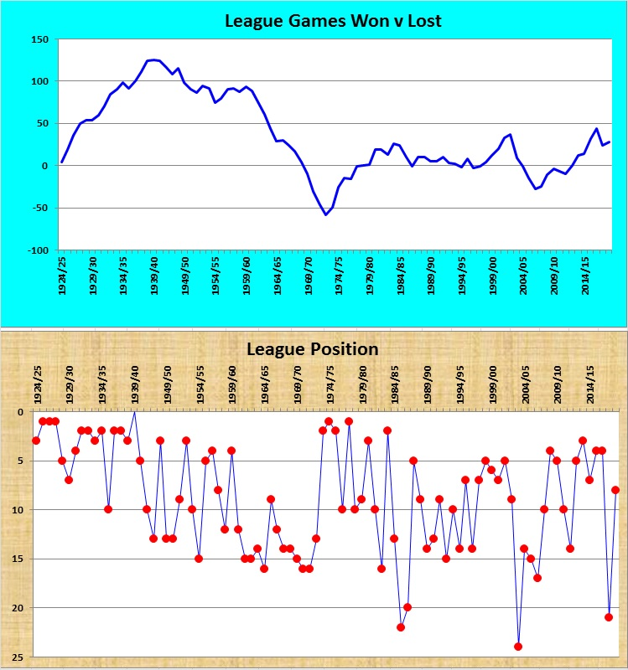

Combined Counties League – Division One
Saturday, 8th February 2020 - Kick-off 3.00 p.m.
Epsom and Ewell  (Royal Blue & White hoops) | V |  | Ash United  (All Green)
Squad | NUMBERS |  | Squad
Conor Young |  |  | Steve McMullen
Ben Ashton |  |  | Jamie Cunnningham
Gideon Acheampong |  |  | Jack Lally
Adam Heagney |  |  | Tom Bale
Lloyd Connelly |  |  | Stan Chilton
Jahmahl King |  |  | Jordan Devaney
Jacob Skelly |  |  | Josh Kipping
Joe Bonass-Ward |  |  | Jack Fitzgerald
Todd Murphy |  |  | James Barnett
Steve Betancourt |  |  | Joe Pantony
© Scott Murphy |  |  | Stan Staines
Corey Haywood-Roye |  |  | Luke Cairns
Jake Robinson |  |  | Nick Holmes
James Fray |  |  | Lewis Old
Tariq Straker |  |  | Neil Hardy
Bobby Bennett |  |  | Jamie Hobbs
Rob Hendry |  |  | Abdul Samad
Taryn Smith |  |  | Matthew Pearse
Jacob Sewell |  |  | Scott Jacques
Tyrell Hallier-Degale |  |  | Cameron Robertson
Jordan-Boateng Anderson
Daniel Duncanson
Sam Morgan | MANAGER |  | Sam Wilson
Tim Moffatt | ASSISTANTS
 | COACHES |  | James Whitehouse
 | PHYSIO
REFEREE: C.Murray
ASSISTANTS: M.Harris, I.Hempel
Today’s match has been kindly sponsored by
long-serving supporters Jeff and Arnold Pye

OUR NEXT VISITORS TO HIGH ROAD
Chessington & Hook United
Combined Counties League – Division One
Saturday, 22nd February 2020 – Kick-off – 3.00 p.m.

